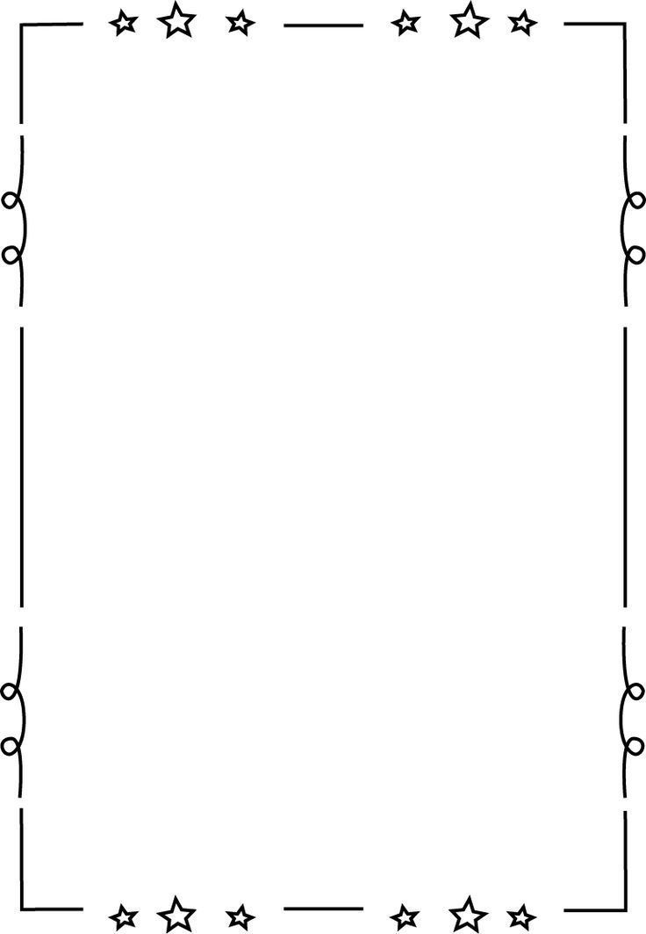**COMMEMORATIVE WALL ORDER FORM**

**ORDER FORMS WILL ONLY BE COLLECTED**

**March 28th UNTIL April 21st**

**LATE ORDERS WILL NOT BE TAKEN DUE TO THE COMPLETION OF THE TILES IN A TIMELY MANNER**

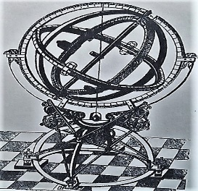

**F**

**E**

**C**

**D**

**A**

**B**

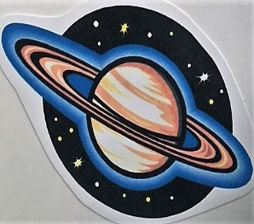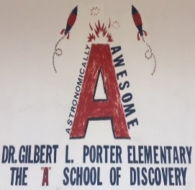

**GLP**

**Dr. Gilbert L. Porter Elementary**

**NAME:__________________________**

**STUDENT NAME:__________________________**

**PHONE:_________________________**

**ENCLOSED IS MY CASH OR CHECK FOR**

**$___________________($25.00/TILE)**

**TOTAL DUE $_____________**

**\*NOTE: IF YOU WOULD LIKE YOUR ARTWORK OR PHOTO RETURNED TO YOU, PLEASE ATTACH A SELF ADDRESSED STAMPED ENVELOPE TO THIS FORM. OTHERWISE THEY WILL BE DISCARDED.**

**PLEASE PRINT CLEARLY**

**_______________________­­­­­­­­­_­­­­­­­___**

**___________________________**

**_________________________**

**YOUR OWN CUSTOM IMAGE OR DRAWING (PLEASE ATTACH PHOTO/ARTWORK)**

**G**

***ADD AN ADDITIONAL $5.00 PER PICTURE***

**PLEASE MAKE CHECKS PAYABLE TO DR. GILBERT PORTER ELEMENTARY PTA**

**THANKS**